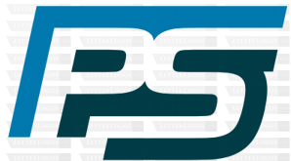
PIONEER SERVICES

PS/SE/001/01/25. Jan 13th , 2025.

M/S NASTP
Silicon Valley, Karachi.

Request for Release of 10% payment for Smoke Extract system Integrated with Fire Alarm System for building No S2, S3 & S4 at NASTP Silicon Valley Karachi.

It is intimated that material for Smoke Extract system has been delivered at site, and physical available for inspection. It is therefore requested 10% payment amounting to Rs 1,889,450/- may please be release as per payment schedule.

Thanking you,
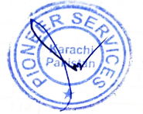

Sincerely yours,
For PIONEER SERVICES.

